4.5 Triple Integrals Worksheet
- The integral of the function over a region R is computed by .
- Mark the box below of the picture of the region R.
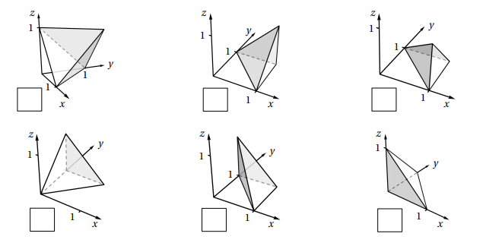

We see that the region of integration is given by:

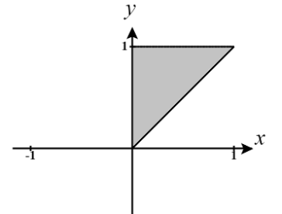

The bounds on z imply that the “floor” of the solid is always at (the xy-plane) and the “ceiling” is given by the plane which implies that when (the red line shown in the picture above) we have that . This immediately allows us to conclude that the region must be the bottom right picture.

OR

The bounds on x and y imply a projection region shown at the right. We can see that only top left and bottom left pictures meet this criteria. Then we can pair this information with the fact that the floor of the region is given by and we can eliminate the top picture.

- Evaluate the iterated integral from part (a).

- Re-express this iterated integral with differentials in the order of dzdydx.

We already know that the region of integration is: .
We note that the projection of E onto the xy-plane (called D) has the following picture.
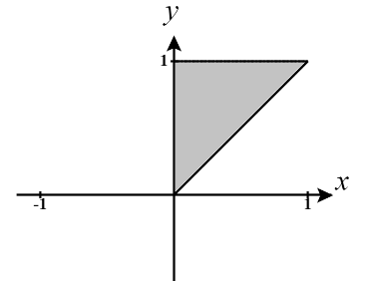

We can represent this region as

Therefore, we express the original iterated integral as

- Re-express this iterated integral with differentials in the order of dydzdx.

Based on the picture of the solid we can see that variable of y is bounded by the plane on the low side and on the high side, so .

We then, note that the projection of E onto the xz-plane (called D) has the following picture.

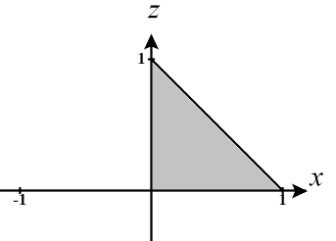
We can represent this region as

Therefore, we express the original iterated integral as

- The integral of the function over a region R is computed by .
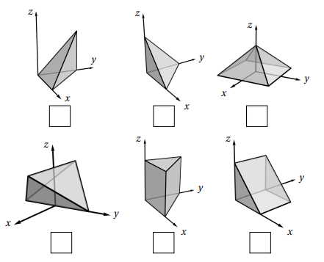

- Mark the box below of the picture of the region R.

We see that the region of integration is given by:

The bounds on z imply that the “floor” of the solid is always at (the xy-plane) and the “ceiling” is given by the plane which implies that the top and bottom of this region should be flat. This immediately leads us to the conclusion that we have the bottom middle region.

OR

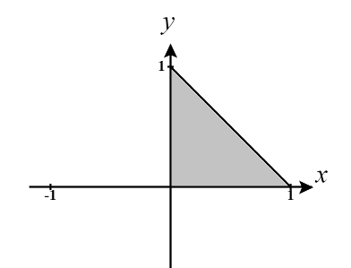
The bounds on x and y imply a projection region shown at the right. We can see that the top left, top middle, and bottom middle have meet this criteria. Then we can pair this information with the fact that the ceiling of the region is given by and we can eliminate the top pictures.

- Evaluate the iterated integral from part (a).

- Re-express this iterated integral with differentials in the order of dzdxdy.

We already know that the region of integration is: .
We note that the projection of E onto the xy-plane (called D) has the following picture.


We can represent this region as

Therefore, we express the original iterated integral as

- Re-express this iterated integral with differentials in the order of dxdydz.

Based on the picture of the solid we can see that variable of x is bounded by the plane on the low side and on the high side, so .

We then, note that the projection of E onto the yz-plane (called D) has the following picture.

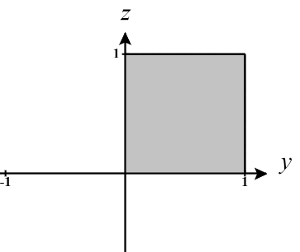
We can represent this region as

Therefore, we express the original iterated integral as


- The integral of the function over a region R is computed by .

- Mark the box below of the picture of the region R.

We see that the region of integration is given by:

The bounds on x imply that the range on the x-coordinate grows as we move higher up the solid (that is to a higher z-coordinate). Only the bottom left picture meets this criteria.

OR

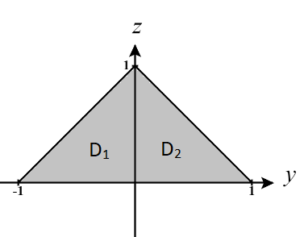
The bounds on y and z imply a projection region shown at the right. We can see that the top right and bottom left regions meet this criteria. Then we can pair this information with the fact that the range on the x-coordinate grows as we move higher up the solid (that is to a higher z-coordinate) and we can eliminate the top picture.

- Evaluate the iterated integral from part (a).

Let then . Our bounds become and . Therefore, our iterated integral becomes:

- Explain why this iterated integral cannot be re-expressed as a single integral with differentials in the order of dxdzdy. Then, re-express this iterated integral as the sum of two integrals with differentials in the order of dxdzdy.

We already know that the region of integration is:
We note that the projection of E onto the yz-plane (called D) has the following picture.


We can immediately see that if we define D with y varying freely from -1 to 1 then we cannot bound z by a single function containing y. Therefore, we cannot rewrite the original integral as a single integral with differentials dxdzdy.

We will split this region into two regions () where

Therefore, we express the original iterated integral as

- Re-express this iterated integral as the sum of two iterated integrals with differentials in the order of dzdydx.

Based on the picture of the solid we can see that variable of z is bounded above by two different planes and bounded below by another two planes. In total there is a combination of 4 different “floor” and “ceiling” functions across the solid.
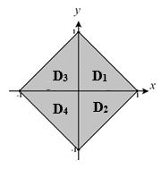
We have that
On the front right
On the front left
On the back right
On the back left
Now we project of the solid into the xy-plane and determine the 4 sub regions of the projection. This region cannot be expressed in a single set and therefore, we break the region into four regions.
Therefore, we express the original iterated integral as
- Consider the solid determine by the region
- Draw a picture of the solid communicated by this integral.
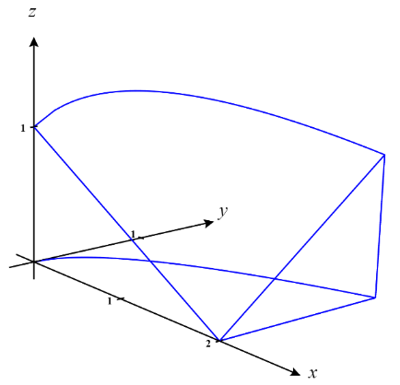
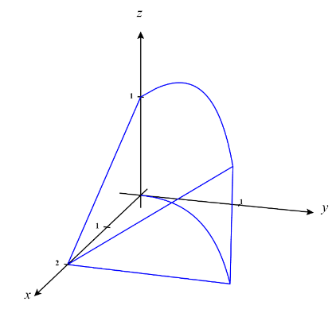

- Set up an iterated integral which represents the volume of this region.

- Rewrite this iterated integral so that the differentials are in the order: .

We note that the projection of E onto the xy-plane (called D) has the following picture.

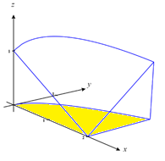
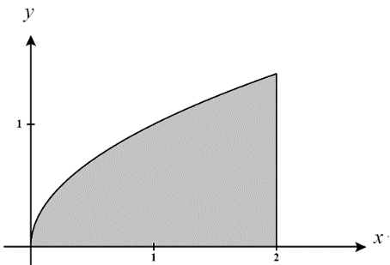

We can represent this region as

Therefore, we express the original iterated integral as

- Suppose is a continuous function. Consider the iterated integral: .

- Draw a picture of the solid communicated by this integral.
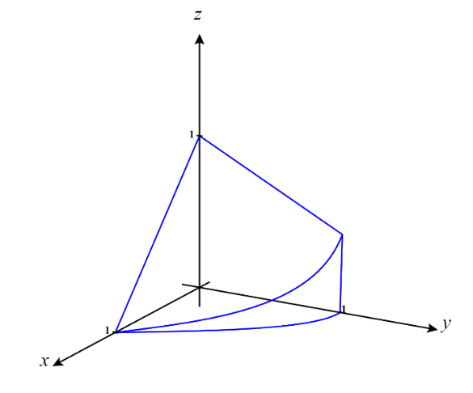
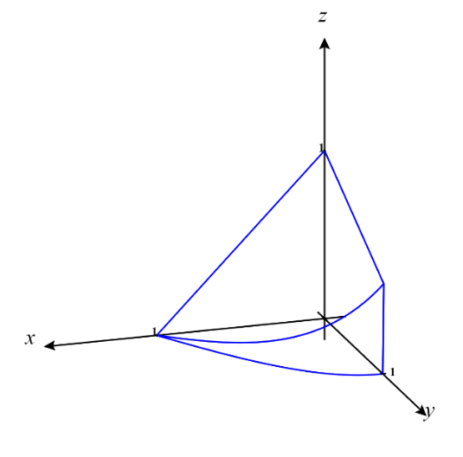

- Rewrite this iterated integral so that the differentials are in the order: .

We see that the region of integration is given by:

We note that the projection of E onto the xy-plane (called D) has the following picture.
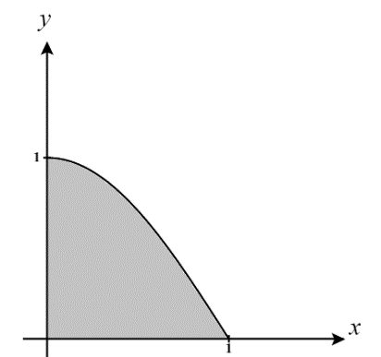

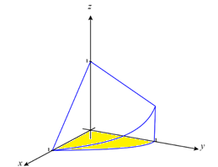
We can represent this region as

Therefore, we express the original iterated integral as

- If E represents the region of integration, then determine the projection of E onto the xz-plane.

We will call the region representing the projection of E on the xz-plane D.
We see that D is the following region.
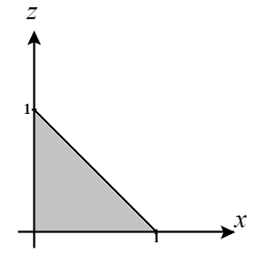
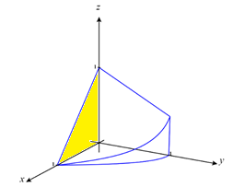

We therefore define D as:

- If E represents the region of integration, then determine the projection of E onto the yz-plane.

We will call the region representing the projection of E on the xz-plane D.
We see that D is the following region.

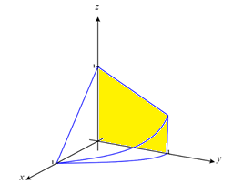
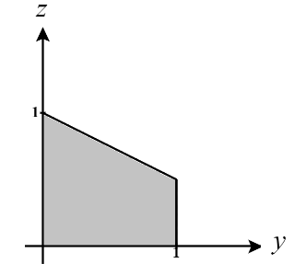

We therefore define D as:

- Suppose is a continuous function. Consider the iterated integral: .
- Draw a picture of the solid communicated by this integral.

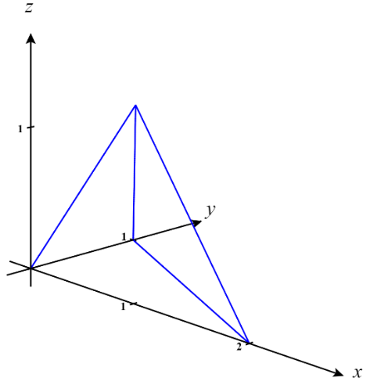
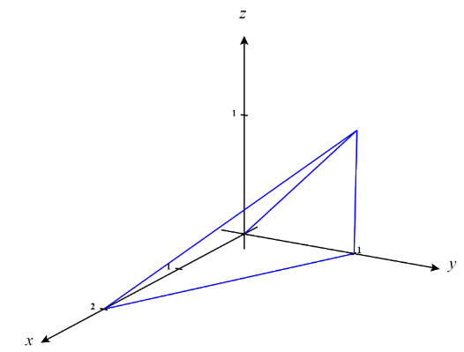

- Rewrite this iterated integral so that the differentials are in the order: .

We see that the region of integration is given by:

We note that the projection of E onto the xy-plane (called D) has the following picture.

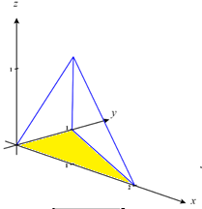
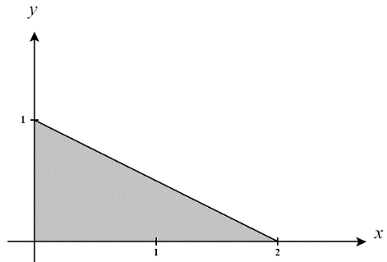
We can represent this region as

Therefore, we express the original iterated integral as

- Rewrite this iterated integral so that the differentials are in the order: .

Based on the picture of the region we see that y is bounded on the low side by the plane and on the side by . Therfore we have the bounds
We then, note that the projection of E onto the xz-plane (called D) has the following picture.
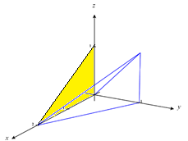
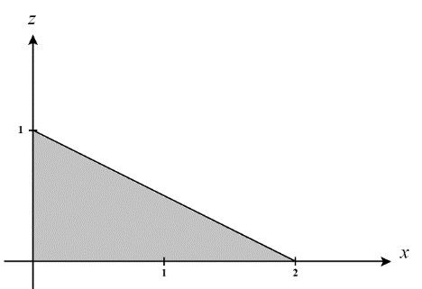

We can represent this region as
Therefore, we express the original iterated integral as

- Rewrite this iterated integral so that the differentials are in the order: .

Based on the picture of the region we see that x is bounded on the low side by the plane and on the side by . Therfore we have the bounds

We then, note that the projection of E onto the yz-plane (called D) has the following picture.
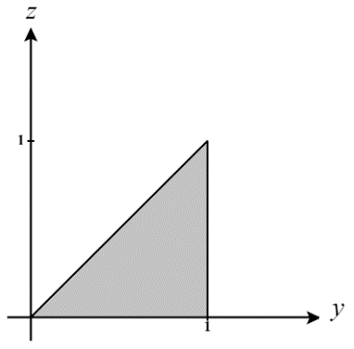
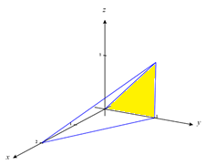
We can represent this region as

Therefore, we express the original iterated integral as

- Let R be the region in the first octant lying below the plane .
- Setup a double integral which computes the volume of R with the differentials dxdy.

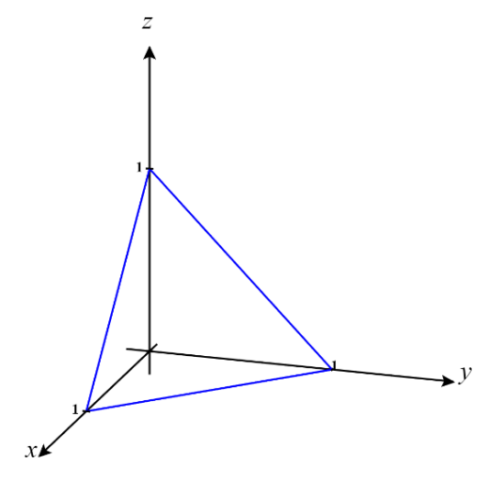
We sketch a picture of the solid E (shown to the right).

We see that the for the given region that .
So, we are just trying to volume that exists beneath the surface and above the xy-plane.

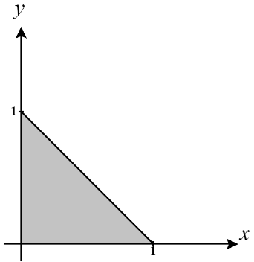
Therefore, we are integrating over the region D shown below.
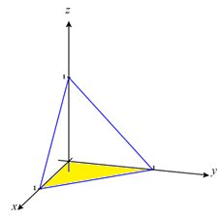

We can represent this region as
Therefore, we can represent the volume of the given region as

- Setup a triple integral which computes the volume of R with the differentials dydxdz.

We see that the for the given region that
We then, note that the projection of E onto the xz-plane (called D) has the following picture.
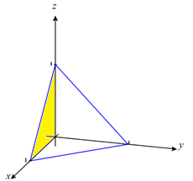

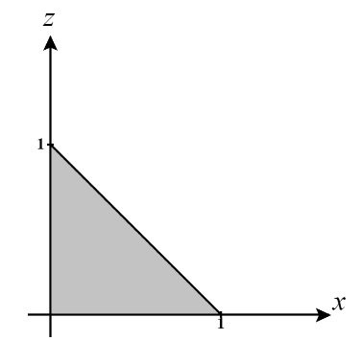

We can represent this region as
Therefore, we express the volume of the region by calculating the .
- Find the volume of the solid bounded by the coordinate planes and the plane .

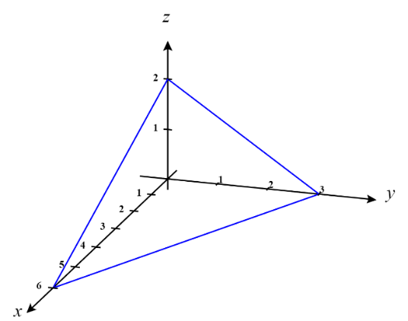
We sketch a picture of the solid E (shown to the right).

We see that the for the given region that .
We then, note that the projection of E onto the xy-plane (called D) has the following picture.
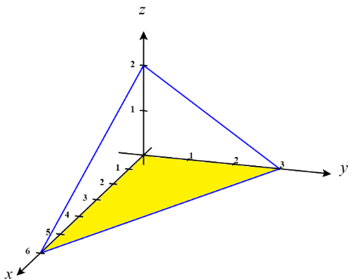

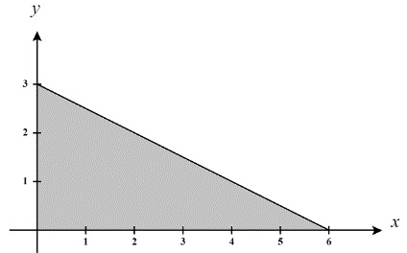

We can represent this region as
Therefore, we express the volume of the region by calculating the .
We calculate.

- Suppose is a continuous function. Consider the iterated integral: .
- Draw a picture of the solid communicated by this integral.

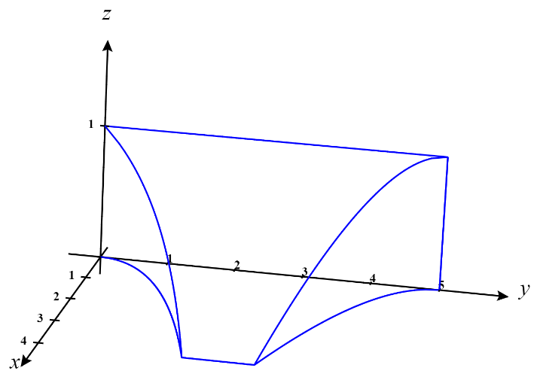
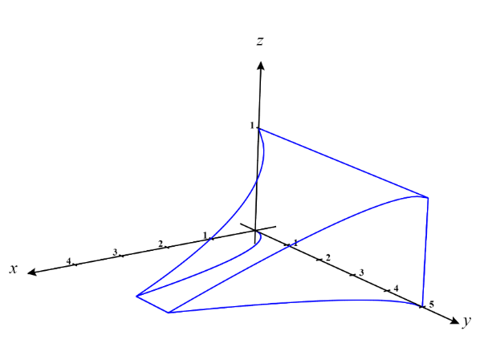

- Rewrite this iterated integral so that the differentials are in the order: .

We see that the region of integration is given by:

Based on the region we see that y is bounded on the low side by and on the high side by . Therefore we have bounds on y of .

We then note that the projection of E onto the yz-plane (called D) has the following picture.

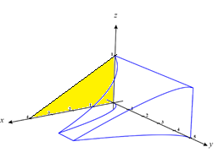
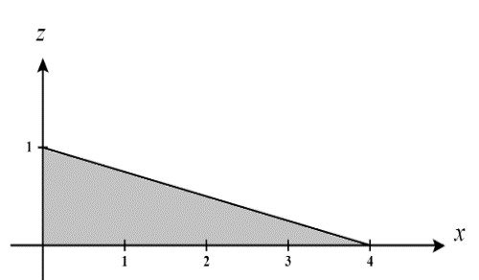
We can represent this region as

Therefore, we express the original iterated integral as

- If E represents the region of integration, then determine the projection of E onto the yz-plane.

We will call the region representing the projection of E on the xz-plane D.
We see that D is the following region.

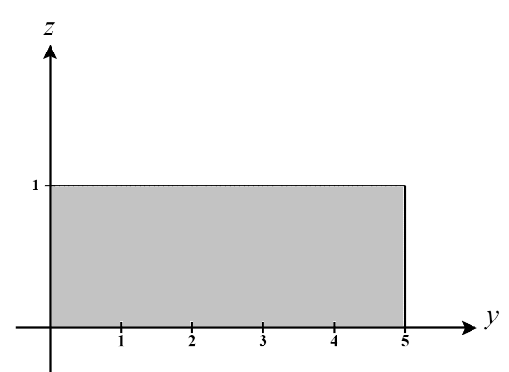
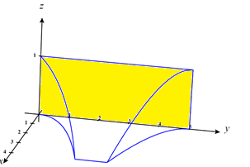

We therefore define D as:

